Introduction
Official documentation about MCP: modelcontextprotocol.io.
MCP is a protocol which enables LLMs to use different tools.
There are two components of MCP:
- MCP server – App where we define different tools which can be used by LLMs.
- MCP client – App where LLM is using tools from a MCP server
In this document we will focus on FastMCP.
FastMCP is an official Python SDK for working with MCP: gofastmcp.com. It makes it easy to create a MCP server and client in Python.

MCP server
MCP server is an app where we define tools which can be used later on by other apps (like accessing a database or using different functions). For example:
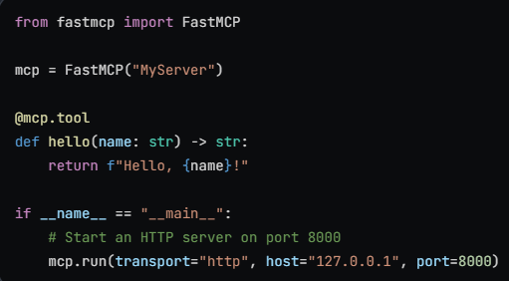
It is similar to Rest API. It is a long running program (it stops when we stop it) and when other app (a MCP client) sends a request, it sends a response.
In a request we tell what tool we want to use and send parameters for this tool.
As a response we receive an output from this tool for those parameters.
Transport protocols determine how clients interact with the server. There are different types, for example:
- STDIO Transport
- HTTP Transport

STDIO Transport
This transport communicates through standard input and output streams.
With STDIO transport, the client spawns a new server process for each session and manages its lifecycle. The server reads MCP messages from stdin and writes responses to stdout. This is why STDIO servers don’t stay running - they’re started on-demand by the client.
This is the default Transport type which is chose when we use run() function without parameters.

HTTP Transport
HTTP transport turns your MCP server into a web service accessible via a URL. This transport uses the Streamable HTTP protocol, which allows clients to connect over the network. Unlike STDIO where each client gets its own process, an HTTP server can handle multiple clients simultaneously.
The Streamable HTTP protocol provides full bidirectional communication between client and server, supporting all MCP operations including streaming responses. This makes it the recommended choice for network-based deployments
We create a HTTP Transport by providing those parameters to the run() function:

MCP client
MCP client is an app which uses tools defined in a MCP server.
For example here is a code which uses a tool from a MCP server which uses HTTP Transport:
